PROJECT DOCUMENTATION
Tableau
Advanced Analytics & Trend Visualization for Network Changes
PROJECT
Automated Network Request Management

Date
Team ID
Project Name | Automated Network Request Management
Maximum Marks

1. Introduction
Alongside operational reporting, the project uses Tableau for deeper, exploratory analytics on network request and change data — identifying trends, correlations, and patterns over time that inform continuous improvement of the automated workflow. Where day-to-day reporting favors dashboards embedded in ServiceNow, Tableau is used for historical trend analysis and cross-dimensional exploration by analysts and process owners.

2. Objective
- Analyze long-term trends in network change success rate and request volume.
- Identify regional or categorical patterns in request density to inform capacity planning.
- Correlate change types with historical failure or rollback rates.
- Enable analysts to explore data interactively beyond fixed operational reports.

3. Data Connection
Tableau connects to ServiceNow-extracted datasets (via scheduled export or the ServiceNow Web Data Connector), combining network request history, change outcomes, and CMDB attributes into an analytical data model suitable for trend and correlation analysis.

4. Sample Analytics View
The visualization below illustrates the type of trend and correlation analysis Tableau enables: change success rate over time, regional request distribution, and a density heatmap of request type by week.
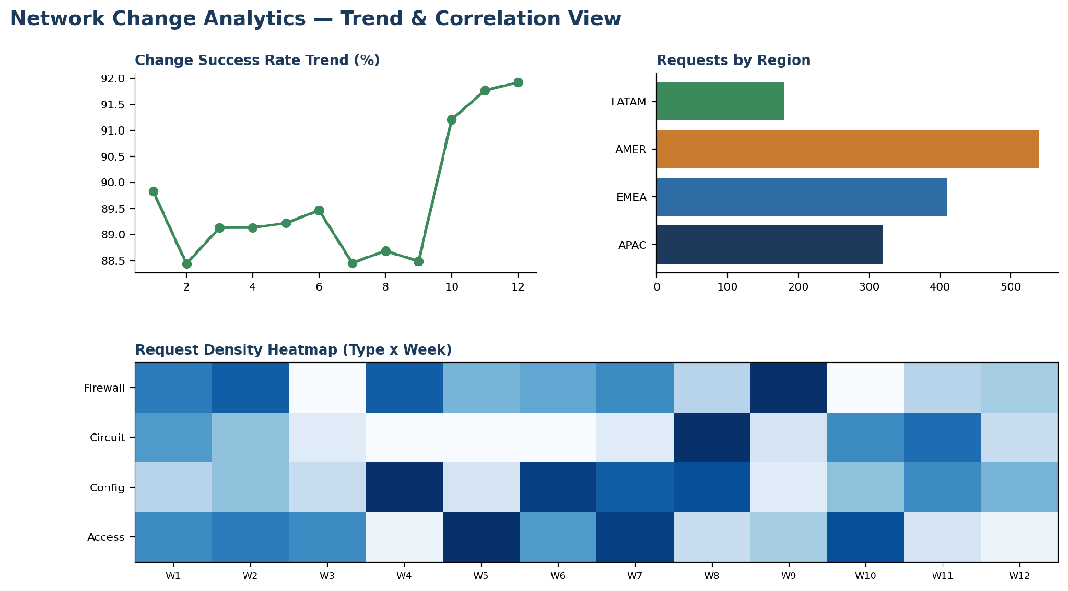
Figure 1: Sample Tableau analytics view for network change trends

5. Analytical Views Delivered
View | Purpose
Change success rate trend | Tracks whether automated changes are becoming more reliable over time
Requests by region | Highlights geographic concentration of demand for capacity planning
Request density heatmap | Shows which request types spike in which weeks, useful for staffing and scheduling
Failure correlation analysis | Explores relationships between change type, CI class, and rollback frequency

6. How This Differs from the Power BI Reporting
Power BI is used for operational, near real-time executive reporting refreshed on a schedule from live ServiceNow data. Tableau complements this with deeper, ad hoc, exploratory analysis of historical data — used periodically by analysts to uncover patterns that inform process changes, rather than for daily monitoring.

7. Benefits to the Project
- Surfaces long-term trends that day-to-day dashboards may not reveal.
- Supports root-cause analysis when change failure rates increase in a specific category or region.
- Informs capacity planning by highlighting demand patterns across time and geography.
- Provides evidence for continuous improvement of the automated workflow's rules and thresholds.

8. Conclusion
Tableau extends the analytical depth of the Automated Network Request Management project, allowing the team to move beyond operational monitoring into trend discovery and root-cause analysis. This supports ongoing refinement of the automation logic and strengthens the evidence base for process improvement decisions.

